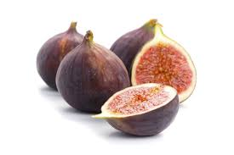 QA Academy – Team Fig

# qaTelerik Academy Learning System

Current Test Report

**Version: 1.0 Date: 10 Oct 2014**

Document History

1. Revision History

|  |  |  |  |
| --- | --- | --- | --- |
| Revision # | Revision Date | **Description of Change** | **Author** |
| 1.0 | 10 Oct 2014 | Current report data | Team Fig |
| 2.0 | 16 Oct 2014 | Current report data | Team Fig |
|  |  |  |  |
|  |  |  |  |
|  |  |  |  |
|  |  |  |  |

Table of Contents

Telerik Academy Learning System 1

1. ITEMS to be tested 2

2. Test Cases Overview 2

3. Test Cases Execution 2

4. Test Cases Automation 3

5. Automated Test Cases Execution 3

6. Bugs Reported 5

# ITEMS to be tested

* “Calendars” module
* “Kids Academy” module
* “Teacher” module
* “Kids Academy” registration form

# Test Cases Overview

* Total amount of test cases – ***237 (previous report 286)***
* New test cases since the last report – ***0***
* Test cases coverage – all items subject to testing except “Teacher” module

# Test Cases Execution

# Test Cases Automation

Implementation, with the chosen approach, according to the test cases priority

# Automated Test Cases Execution

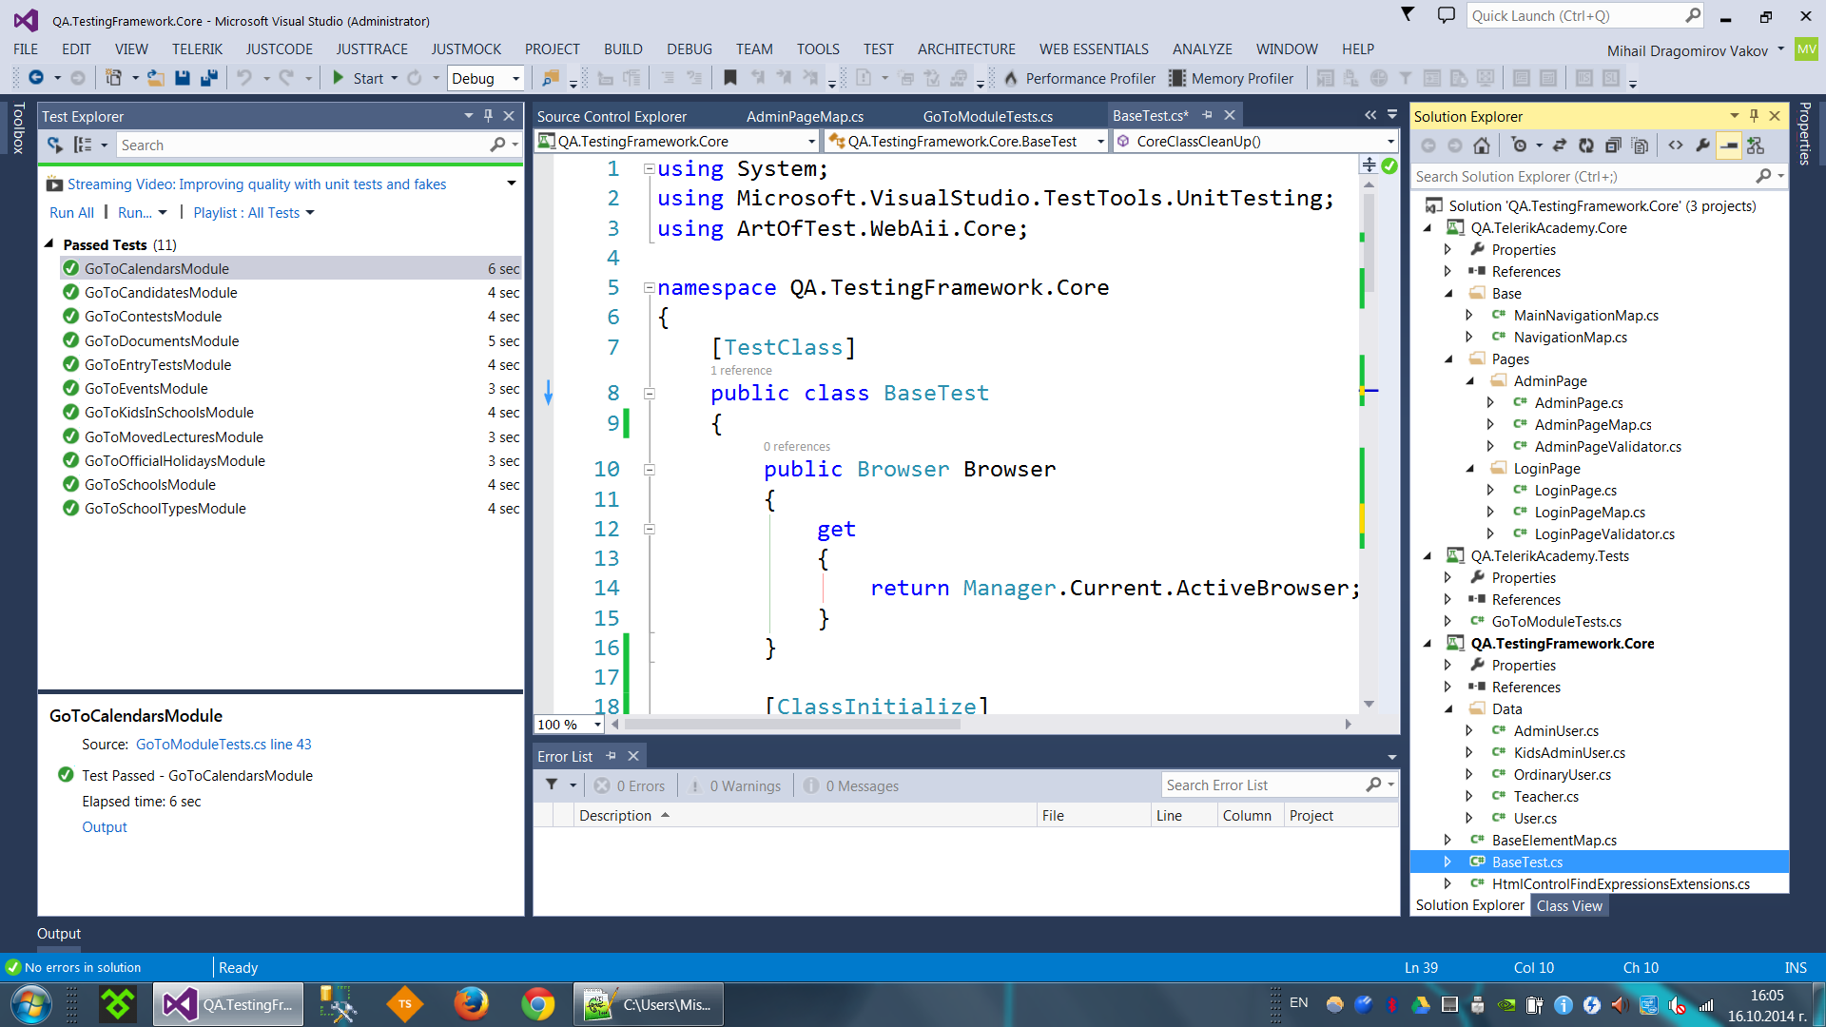

# Bugs Reported

* Total amount of reported bugs – ***0***